Programming Skills : Laboratory Background Information

Using the Spyder Integrated Development Environment, and Jupyter Notebooks
It is perfectly possible to write a text file containing your computer programs in a text editor of your choice; invoke the various compilers, linkers and loaders that you need in order to turn a complied language into machine code from the computer command line; and then run the program from that command line.
It is rather simpler to use an interpreted language, where commands are entered one after the other (like a desk calculator on steroids) or where the interpreter is fed a text file of commands in one go.
However, all programmers make mistakes, and the more mature the programmer, the more subtle the mistiakes. So we use Integrated Development Environments to write anything other than the simplest programs. An IDE usually contains a text editor, tools to sort through the piles of program files you have written, a method of easily flagging errors and quickly getting you to the lines of your program that caused those errors, and an easy way to see the values of your variables as you step through your programs.
Because IDEs are designed for professional programmers, they have a profusion of parameters and options, and sometimes seem confusing to beginners – however, you will very quickly find yourself able to ignore all the options that you don’t need, and just concentrate on writing, compiling and testing code. We will use the free Spyder (Scientific Python Development Environment) as our IDE of choice, although if you wish, you can use the commercial Microsoft Visual Studio 2019 Development Environment also installed on all the Engineering Computer Clusters (Microsoft has a freeware IDE called VSCode, which is also installed and looks like it will be nice in future, but it crashed too often last year to be worth recommending unless you really want to try it.)
In addition, for small/simple computer programmes or for programmes where you’ve already done the debugging, and now want to present what you have done in context of an Engineering problem—especially for Engineers or Scientists who are used to keeping a lab book—Jupyter Notebooks are extremely useful. They contain sets of cells, some of which are descriptive text, some data, some code, and some output plots, and you can run the code cells and update the plots all within the Notebook itself. We will use Jupyter Notebooks to present you with example problems and have you report on the results of your programming.

Note that due to Covid-19 we will be using virtual PCs rather than physical lab PCs. These can be accessed from :
https://www.gla.ac.uk/myglasgow/anywhere/desktop/
but once you’ve logged in you get to work on a virtual PC in the ‘cloud’ in just the same way as a you would whilst sitting in the James Watt South Computer cluster (you don’t even need to install anything on your own computer unless you want to use audio and video whilst using the virtual PC) . Although virtual PCs can be set up for timed use for particular courses, all the software licences for this courses are already installed, and so you can use the virtual PC whenever you wish.

A: Getting Started with the Spyder IDE
NOTE: you can download the Spyder IDE, Jupyter Notebooks and some other useful Python tools yourself as part of the Anaconda Distribution from anaconda.com. Ignore the Enterprise version, and get the Python 3.x Anaconda Distribution version for your Operating System. It’s usually about 0.5 Gb of download.

Fig A1 : Go get Anaconda !
On the Lab PCs, Anaconda Navigator is invoked from the Windows menu. Once it starts you should be presented with a menu of applications. Just launch Spyder.
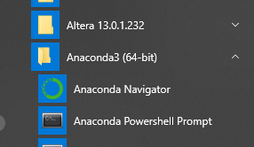
Fig A2 : Opening Anaconda Navigator from Windows menu on the lab PCs
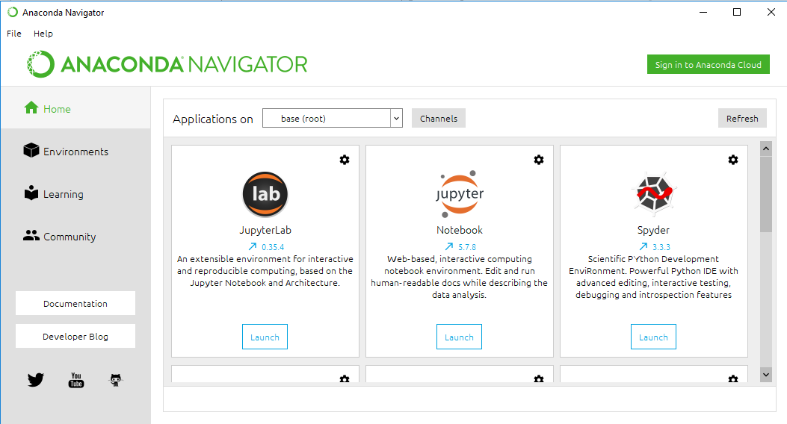
Coding Window
Fig A3 : Anaconda Navigator – open Spyder.

Code Debug Shortcuts
Code Running Shortcuts

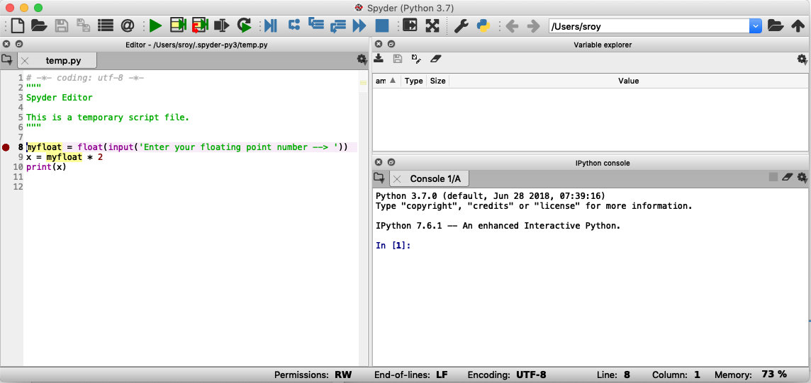
Variable values
Coding Window
Line-at-a-time code
and code Outputs

Fig A4 : Spyder Window

Once the Spyder IDE starts, choose to create a new project from the ‘Projects’ menu. You will, of course, have to name your project – “MyLab1” would be fine, although you can be more descriptive if you like – and save the project in a directory on your home drive (i.e. somewhere in your M: student directory) so that you can find it in future on any machine. Every time you use Visual Studio to do a new programming exercise, create a new project. It makes life a lot simpler down the line.
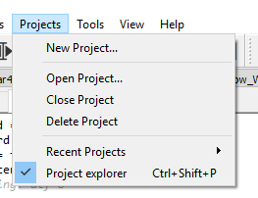
Fig A5 : How to create a New project
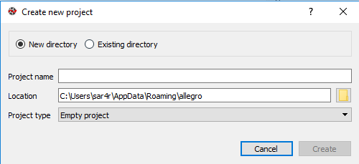
Fig A6 : Naming a new project – one for each programming exercise.
A project explorer window opens at the left hand side of Spyder. Right click on the folder you just created in order to create a new file into which you will write your code. Make the new file an empty Python file, and name it with a .py suffix.

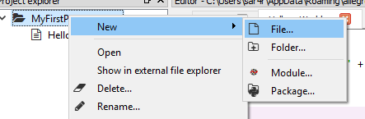
Fig A7 : Creating a file for your code.

OK, now try typing in your first Python code into this new file.
first_word = ‘Hello’
second_word = ‘World’
two_words = first_word + ‘ ‘ + second_word
print(two_words)
You will find that the text editor, knowing that you are writing in Python, will try to autocomplete your choices, and colour the code so that you can be more confident that it’s correct. Code you have chosen will be in black and strings such as ’Hello’ will be in green. Reserved words such as if and for will be in blue, but you haven’t written any of those yet, and function names in magenta You can save your text from the File menu or disk shortcut.
Now you need to run your code. Simply pushing the green ‘play’ button should do the trick. Have a play to see how things work!
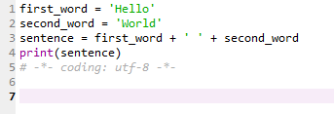
Fig A8 : Code autoformatted
I then tried taking out the underscore in the variable second_word. The IDE noticed that there was a problem, and coloured the left hand bar to warn me. In addition, when I tried to run the code the output flagged that I’d done something stupid, and the line on which the problem occurred. One of the joys of programming is trying to work out where the bugs are in a program, based on a cryptic set of IDE hints.

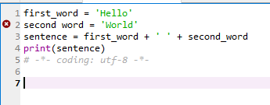
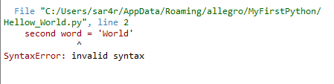
Fig A9 : Syntax errors
Make sure that your version of this code has no errors. If you have problems, talk to the nearest lab demonstrator.
As an additional, very useful piece of knowledge, the other way to stop your program from finishing too quickly to see, is to add Breakpoints. These are flags in the code to tell it to stop and wait. In addition, at a breakpoint, you can get the IDE to display the values of all the variables in the code. This turns out to be spectacularly useful in the debugging process. Just click in a program line and then choose ‘Debug’->’Set Breakpoint’ to get red breakpoint dots (I’ve added two here).
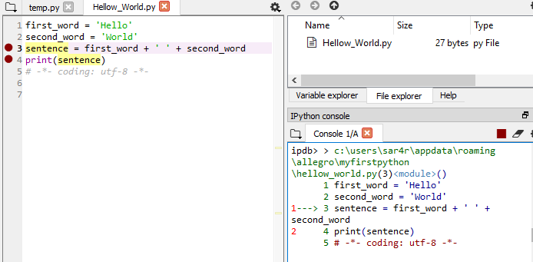
Fig 9 : Adding a breakpoint
When you run the code, this time do it with ‘Debug’->’Debug’ or the Blue run button. The code will stall at each breakpoint, and you can view the value of code variables at that point in the ‘Variable Explorer’ Window. If you click the ‘Continue’ button, the code stops at the next breakpoint (the next line), and you get the value of all the variables there. This turns out to be really useful when you are completely stumped about why your code doesn’t do the right thing.
You are now ready to try your hand at actually learning practical Python !

B: Using Jupyter Notebooks
In section A you used the Anaconda launcher to open Spyder. A Jupyter Notebook is opened from the same launcher.
Fig B1 : Anaconda Navigator – also allows you to open Jupyter Notebooks
Usually this is all you need to do – Jupyter Notebooks opens in a web browser, and shows your directory structure so that you can open the notebooks that we have built for you. (You download from Moodle and store in a folder on the PC.) However, depending on exactly how things were installed, the system might not point things to the correct directories. In this case, use the Windows menu and open Anaconda Prompt, rather than Anaconda Navigator. This will open a Command Window, into which you can type “M:” to change to your student directories, and then “jupyter notebook” to launch the web browser pointing to those files
Notebook files are suffixed “.ipynb”, and can be opened from the directory structure, and then browsed at will. They are easy, to edit a cell you merely open it and type. To run code you just select a cell and type ‘Shift-Return’ or ‘Ctrl-Enter’
You will find an introduction.ipynb file on the IP2 Moodle site. Download it and open it in Jupyter Notebooks.

C: Getting started with Microsoft Visual Studio (OPTIONAL)
If you want to use the commercial Integrated Development Environment on the Engineering PCs, It is invoked from the Windows menu ‘Visual Studio 2019’. (Microsoft will allow you free access to Visual Studio as a student, but once you graduate to will need to pay for its use).
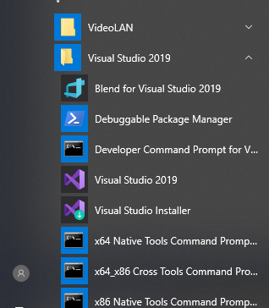
Fig C1 : How to Open Microsoft Visual Studio 2019
Once the IDE starts, choose to create a new project, and use the drop down menu to find the Python projects available. The first Python project is ‘A project for creating a command line application’ which will be fine. You will, of course, have to name your project – “MyLab1” would be fine, although you can be more descriptive if you like – and save the project in a directory on your home drive (i.e. somewhere in your M: student directory) so that you can find it in future on any machine.
Every time you use Visual Studio to do a new programming exercise, create a new project. It makes life a lot simpler down the line.
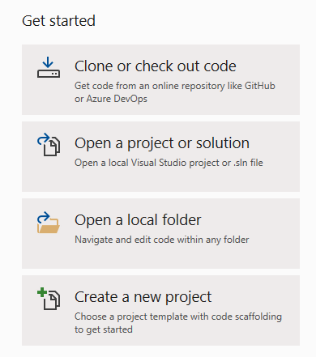
Fig 2 : How to create a New project – use last button
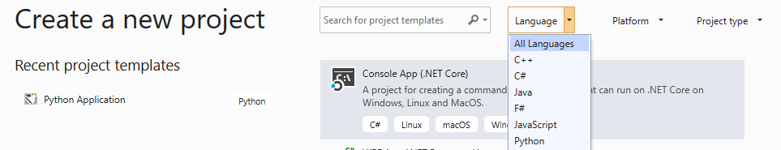
Fig 3 : How to make sure you only see Python projects
The IDE will show a set of windows. Along the bottom is an output/error list window, which will show you the results of your coding attempts. The large space will contain your actual code, but it’s blank because you haven’t written anything yet. Normally this will be headed by something like ‘MyApplication.py’, because the system creates a first text file for Python programming for you. However, if you need to, you can add new source files, so right-click on the project folder in the Solution Explorer window and Add a New Item…, and make that new item an empty Python file.
OK, now try typing in your first Python code into this new file.
first_word = ‘Hello’
second_word = ‘World’
two_words = first_word + ‘ ‘ + second_word
print(two_words)
You will find that the text editor, knowing that you are writing in Python, will try to autocomplete your choices, and colour the code so that you can be more confident that it’s correct. Normal code will be in black and strings such as ’Hello’ will be in red (reserved words such as if and for will be in blue, but you haven’t written any of those yet). You can save your text by right clicking on the <name.py> tab at the top of this window.
Now you need to run your code. Either right click in your .py text and ‘Start without Debugging’ or selecting ‘Start without Debugging’ from the ‘Debug’ menu, or simply pushing the green ‘play’ button should do the trick. This runs the whole script – but if you want you can run each line one by one by using ‘Cntl-Enter’. Have a play to see how things work! Also mouse-over various bits of text in your code – the system should tell you what sort of item you are mousing over. This can be useful to see if you and the system agree on the nature of your bits of code.
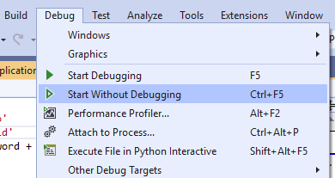
Fig 5 : Running your program
I then tried taking out the underscore in the variable second_word. The IDE noticed that there was a problem, coloured the left hand bar yellow to warn me, and underscored the problems in red. Mousing over gives additional hints to what might have gone wrong. One of the joys of programming is trying to work out where the bugs are in a program, based on a cryptic set of IDE hints.
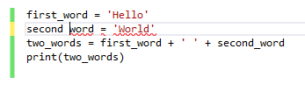
Fig 6 : Syntax errors
Make sure that your version of this code has no errors. If you have problems, talk to the nearest lab demonstrator.
As an additional, very useful piece of knowledge, the other way to stop your program from finishing too quickly to see, is to add Breakpoints. These are flags in the code to tell it to stop and wait. In addition, at a breakpoint, you can get the IDE to display the values of all the variables in the code. This turns out to be spectacularly useful in the debugging process. Just click in the left hand margin of the program to get the following red dot
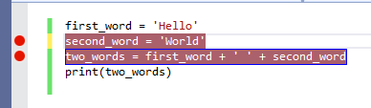
Fig 9 : Adding a breakpoint
When you run the code, this time do it with ‘Start with Debugging’. A new window will open called ‘Locals’ with the values of the variables at the first breakpoint (red dot). If you click the ‘Continue’ button, the code stops at the next breakpoint (the next line), and you get the value of all the variables there. In addition, mousing over the variables, brings up their values. This turns out to be really useful when you are completely stumped about why your code doesn’t do the right thing.
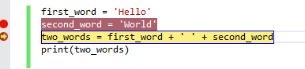
Fig 10 : Stalled at a breakpoint, with the ‘Locals’ window showing the value of variables

You are now ready to try your hand at actually learning practical Python !

